**NORMAL DISTRIBUTION**,

Data is symmetrically distributed with no [skew](https://www.scribbr.com/statistics/skewness/). When plotted on a graph, the data follows a bell shape, with most values clustering around a [central region](https://www.scribbr.com/statistics/central-tendency/) and tapering off as they go further away from the center.

Understanding the properties of normal distributions means you can use [inferential statistics](https://www.scribbr.com/statistics/inferential-statistics/) to compare different groups and make estimates about populations using samples.

Normal distributions have key characteristics that are easy to spot in graphs:

* The [mean](https://www.scribbr.com/statistics/mean/), [median](https://www.scribbr.com/statistics/median/) and [mode](https://www.scribbr.com/statistics/mode/) are exactly the same.
* The distribution is symmetric about the mean—half the values fall below the mean and half above the mean.
* The distribution can be described by two values: the mean and the [standard deviation](https://www.scribbr.com/statistics/standard-deviation/).

The mean is the location parameter while the standard deviation is the scale parameter.

The mean determines where the peak of the curve is centered. Increasing the mean moves the curve right, while decreasing it moves the curve left.

The standard deviation stretches or squeezes the curve. A small standard deviation results in a narrow curve, while a large standard deviation leads to a wide curve.

**Empirical rule**

The **empirical rule**, or the 68-95-99.7 rule, tells you where most of your values lie in a normal distribution:

* Around 68% of values are within 1 standard deviation from the mean.
* Around 95% of values are within 2 standard deviations from the mean.
* Around 99.7% of values are within 3 standard deviations from the mean.

**Central limit theorem**

The [central limit theorem](https://www.scribbr.com/statistics/central-limit-theorem/) is the basis for how normal distributions work in statistics.

In research, to get a good idea of a[population](https://www.scribbr.com/methodology/population-vs-sample/) mean, ideally you’d collect data from multiple [random samples](https://www.scribbr.com/methodology/simple-random-sampling/) within the population. A **sampling distribution of the mean** is the distribution of the means of these different samples.

**Formula of the normal curve**

Once you have the mean and standard deviation of a normal distribution, you can fit a normal curve to your data using a **probability density function**.

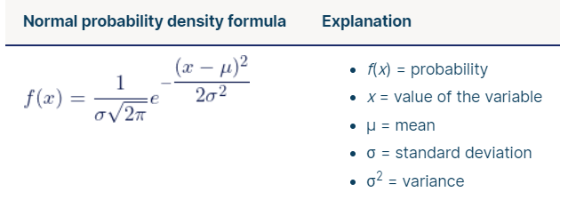

**What is the standard normal distribution?**

The [**standard normal distribution**](https://www.scribbr.com/statistics/standard-normal-distribution/), also called the ***z*-distribution**, is a special normal distribution where the mean is 0 and the standard deviation is 1.

Every normal distribution is a version of the standard normal distribution that’s been stretched or squeezed and moved horizontally right or left.

While individual observations from normal distributions are referred to as*x*, they are referred to as *z* in the *z*-distribution. Every normal distribution can be converted to the standard normal distribution by turning the individual values into *z*-scores.

*Z*-scores tell you how many standard deviations away from the mean each value lies.

You only need to know the mean and standard deviation of your distribution to find the *z*-score of a value.

| ***Z*-score Formula** | **Explanation** |
| --- | --- |
| z=\dfrac{x-\mu}{\sigma} | * *x* = individual value * μ = mean * σ = standard deviation |

We convert normal distributions into the standard normal distribution for several reasons:

* To find the probability of observations in a distribution falling above or below a given value.
* To find the probability that a sample mean significantly differs from a known population mean.
* To compare scores on different distributions with different means and standard deviations.

**Finding probability using the *z*-distribution**

Each *z*-score is associated with a probability, or [*p*-value](https://www.scribbr.com/statistics/p-value/), that tells you the likelihood of values below that *z*-score occurring. If you convert an individual value into a*z*-score, you can then find the probability of all values up to that value occurring in a normal distribution.

**Example**: Finding probability using the *z*-distributionTo find the probability of SAT scores in your sample exceeding 1380, you first find the *z*-score.

The mean of our distribution is 1150, and the standard deviation is 150. The *z*-score tells you how many standard deviations away 1380 is from the mean.

| **Formula** | **Calculation** |
| --- | --- |
| z=\dfrac{x-\mu}{\sigma} | z=\dfrac{1\,380-1\,150}{150} z=1.53 |

For a *z*-score of 1.53, the *p*-value is 0.937.  This is the probability of SAT scores being 1380 or less (93.7%), and it’s the area under the curve left of the shaded area.

To find the shaded area, you take away 0.937 from 1, which is the total area under the curve.

Probability of *x*> 1380 = 1 – 0.937 = **0.063**

That means it is likely that only 6.3% of SAT scores in your sample exceed 1380.